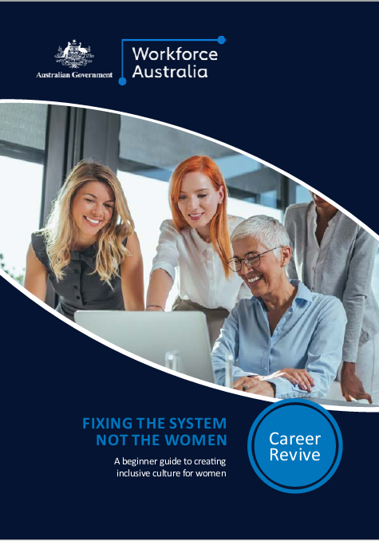

Contents

Introduction and overview 3

The case for equity and inclusion 4

Investment areas 5

Defining the challenge 6

Data driven approach 7

Metrics 8

Priorities 8

Hiring and selection 10

Leadership 11

Norms 12

Progression 13

Retention 14

Policies 15

Evaluation 16

Debiasing systems 17

Managing bias across the talent lifecycle 18



# Introduction and overview

Fairness and equity have quickly become one of the defining issues for organisations. In the post pandemic era, it is more important than ever that women have equal rights, responsibility and opportunity in society and in the workplace.

There are no grand gestures that will solve systemic problems of inequity and homogeneity in our workforces.

What does exist, are a series of evidence-based interventions which, with persistence, can help unearth biases (unconscious or otherwise) which advantages or exclude others.

About the Toolkit

The Toolkit is for organisations seeking to identify and disrupt bias across the talent lifecycle. The kit includes detailed guidance on:

* Using organisational data to identify and shape interventions
* Identifying and disrupting bias in attraction, recruitment and retention.

Definitions

One of the stuck patterns of inclusion work is the language that is used and applied, which influence perceptions and behaviours. The Toolkit defined equity, diversity and inclusion (EDI) as follows:

**Diversity is about people.** This includes their demographic differences, backgrounds, multiple identities, and their unique experiences, perspectives, knowledge, abilities, ideas and more.

It is not referencing specific characteristics of only the minority within a group of people or in society. Diversity is referencing all people and difference among us. Diversity is a mix of all of us.

**Inclusion** ensures that diversity of knowledge, perspectives, information and ideas are being used and applied when we collaborate, solve tasks, develop, innovate and make decisions.

**Equality** means each individual or group of people is given the same resources or opportunities. On the other hand, equity recognises that each person has different circumstances and allocates the exact resources and opportunities needed to reach an equal outcome. Equity encompasses a balance of power and correcting where inequality exists.

## The case for equity and inclusion

The arguments for addressing EDI present differently across regions, organisations and time. The case for investment today, tends to fall into one of four buckets: the business case, the legal case, the fairness and equity case and the talent case.

People from diverse backgrounds alter the behaviours of the social majority in ways that ‘lead to fewer instances of group think.’

|  |  |
| --- | --- |
| **1 The Business Case** | 2 The Legal Case |
| The business case demonstrates the value that diversity, equity and inclusion brings to the company and its constituents.  Companies with higher gender diversity in executive teams were 25% more likely to have above-average profitability than others.  People from diverse backgrounds alter the behaviours of the social majority in ways that ‘lead to fewer instances of group think.’ | Many organisations are driven by compliance with legislation which ensures adherence to government mandates.  In Australia, the Sex Discrimination Act makes it unlawful to discriminate against a person because of their sex, gender identity, intersex status, sexual orientation, marital or relationship status, family responsibilities, because they are pregnant or might become pregnant or because they are breastfeeding. The maximum penalty for unlawful discrimination is $66,600 per contravention for a corporation, and $13,320 per contravention for an individual. |
| **3 The Fairness and Equity Case** | **4 The Talent Case** |
| The equity case is a value driven rationale founded on the belief that equity and inclusion is the right thing to do and regardless of their identity, everyone should have access to opportunities resulting in a more just, equal and fair society.  The cost of exclusion shows up in hundreds of studies as being harmful to individual performance, wellbeing and sense of purpose. Individuals who experience discrimination are more likely to suffer from stress, long term unemployment, social exclusion, outdated skills and mental health decline. | Skills shortages and labour market tightness is leading businesses to focus on equity, diversity and inclusion to tap into segments of the market that may be underutilised.  A report by consulting firm Korn Ferry found that by 2030, more than 85 million jobs could go unfilled because there are not enough people to take them.  Companies with a reputation for having a healthy culture, experienced lower than average turn over during the first six month of the great resignation. |

Research by Georgetown University found that inclusion efforts grounded in anti-discrimination law, or the legal case, were more likely to promote equitable behaviours than emphasising the businesses case. This may be because the moral and historical grounding of the law legitimises Equity, Diversity and Inclusion (EDI) efforts with more authority, as compared with the more transient financial motivation.

## Investment areas

There are a number of approaches that have been shown to improve EDI outcomes. While the focus areas below are by no means exhaustive, they will help you redesign organisations to prevent biased choices and change beliefs.

|  |
| --- |
| Data Driven Approaches |
| Using data to surface invisible issues and invest in areas accordingly. |
| See Defining the challenge |

|  |
| --- |
| Systemic Interventions |
| Targeting efforts at debiasing systems, not people. |
| See Debiasing systems |

We need to stop focusing exclusively on helping people to navigate systems that remain fundamentally unfair. We need to start changing the systems.

Joan. C Williams, Distinguished Professor of Law and   
UC Hastings Foundation Chair and Director of the Centre for WorkLife Law

When debiasing systems, the same principle always applies. Do whatever you can to take instinct out of consideration and rely on hard data.

Iris Bohnet, Director of the Women and Public Policy Program at the Harvard Kennedy School

At times there may be a tendency to focus efforts on bringing women into organisations rather than considering the environment that they are entering. A more holistic approach may be to look at the end-to-end experience that women have in the workplace, paying close attention to those who stay, those who go, those who flourish and those who drop out of the workforce entirely.

# Defining the challenge

## Data driven approach

Whether you are starting at the beginning or seeking to renew your approach, it is important to begin with an honest assessment of businesses priorities, processes and culture. A data driven approach will help you to surface invisible issues and invest efforts accordingly.

The diagnostic below presents some of the levers that may be impacting your ability increase the presence and impact that women have in your organisation.

Reflective questions and sources of data have been included on pages 8 -20 to help you to initiate the diagnostic process.

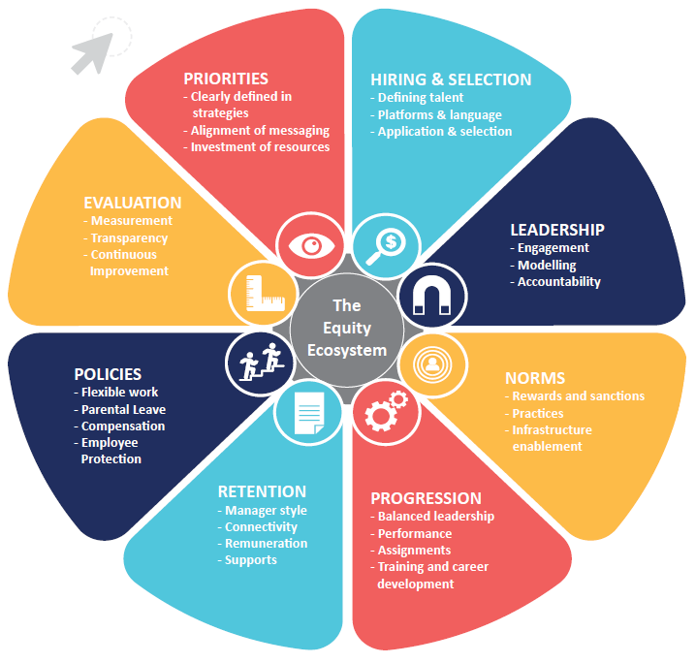

# Metrics

To identify areas for investment and improvement in your organisation, consider the questions and data points below.

While reviews can be conducted internally, organisations may also benefit from engaging an external reviewer.

|  |  |
| --- | --- |
|  | Priorities |

|  |  |
| --- | --- |
| **Consider:** | Data Points: |
| * How explicitly have we defined our gender and equity goals and commitments? * Have we articulated goals which are specific, measurable, achievable and time bound? * Have we established internal targets for gender representation and equity? * Have we considered and designed for intersectionality? | * EDI Strategy / Equity Strategy or Policy. * *Sample survey questions:* Our organisation is genuinely committed to equity and diversity.   ❑ Agree ❑ Disagree   * Employees of different ages are valued equally by our organisation.   ❑ Agree ❑ Disagree   * Our organisation demonstrates a commitment to meeting the needs of employees with disabilities.   ❑ Agree ❑ Disagree |
|  |  |
| * Have we clearly communicated why equity, diversity and inclusion is good for everyone, good for the bottom line, and good for our customers , partners and shareholders? | * Business Strategy. * Annual Report. * Strategic Planning Day Agenda. * *Sample survey question:* I believe having a diverse, equitable and inclusive culture is critical to business success?   ❑ Agree ❑ Disagree |
|  |  |
| * Do we offer leaders and managers effective supports to foster equitable and inclusive cultures and enhance diversity? * Do we recognise and value the time and investment of sponsors and champions? * Do we have a dedicated resource / working group to progress the EDI agenda? * Do leaders provide strategic insight in relation to EDI? * Are we recognising and rewarding the contribution of those who are progressing this work? | * Existence of training opportunities for executive, managers and staff, including training for hiring managers and selection panels. * Protected time / time codes for work that contributes to advancing the EDI agenda. * Budget and resources for EDI activities, including EDI personnel. * *Sample survey questions:* In my experience professional development opportunities have helped me to promote equity in our practice.   ❑ Agree ❑ Disagree   * In my experience, professional development opportunities help me promote culturally responsible practice in my team and amongst my peers.   ❑ Agree ❑ Disagree |
|  |  |
| * Do we talk regularly about our commitment to gender inclusive workplaces? * Do we share and celebrate success? | * Existence of Employee Resource Groups. * Evidence of an EDI communications plan / strategy. * Review of communications materials and platforms. * Recognition of cultural / religious celebrations. * *Sample survey question:* We take time to recognise and celebrate the diversity of our workforce and team.   ❑ Agree ❑ Disagree |
|  |  |

|  |  |
| --- | --- |
|  | Hiring and selection |

|  |  |
| --- | --- |
| **Consider:** | Data Points: |
| * How frequently are we reviewing role descriptions, job advertisements and selection criteria? * Are we offering flexible work by default in our advertisements? * How clear have we made expectations around negotiations and salary? * Might our definition of ‘culture fit’ exclude some members of society? * Are we emphasising traits or attributes that may be exclusionary? | * Review language, skills, qualifications and capabilities specified in job advertisements and focus only on minimum requirements. * Review interview questions to determine whether questions may inadvertently be excluding some groups. |
|  |  |
| * Are we favouring certain talent sources over others based on historic success? * How reliant are we as an organisation on referrals or hiring through alumni networks? * Are we discounting individuals with career gaps in their CVs? * Are we considering candidates from a broad variety of universities and non-traditional education backgrounds? | * Examine potential applicant pools – including the proportion of the pool with relevant qualifications and experience. * Review CVs of successful candidates to see if there are common patterns among applicants who do progress to offer. * *Sample survey questions:* Our organisation takes active measures to seek a diverse candidate pool when hiring.   ❑ Agree ❑ Disagree   * There is diversity among the people a job candidate will meet/see on their first visit to the company.   ❑ Agree ❑ Disagree |
|  |  |

|  |  |
| --- | --- |
|  | Leadership |

|  |  |
| --- | --- |
| **Consider:** | Data Points: |
| * Is there diversity in our leadership teams? * Do our female and male leaders have the same level of influence and quality of experience? | * Consider split by seniority, unit and department. * *Sample survey questions:* Female leaders in our organisation have less influence than males at the same level.   ❑ Agree ❑ Disagree   |  | | --- | | (Provide an example of where this has occurred) |  * Female leaders in our organisation do more ‘housework’ than our male colleagues.   ❑ Agree ❑ Disagree   |  | | --- | | (Provide an example of where this has occurred) |  * Engage an independent party to audit meetings. * Consider who is being spoken over and whose views are being recognised. |
|  |  |

|  |  |
| --- | --- |
|  | Norms |

|  |  |
| --- | --- |
| **Consider** | Data points |
| * How would our people describe the culture in our organisation? * Would they refer in a friend? A daughter? | * *Sample survey questions:* At this company, employees appreciate others whose backgrounds, beliefs and experiences are different from their own.   ❑ Agree ❑ Disagree   * Employees of different backgrounds interact well in our organisation.   ❑ Agree ❑ Disagree   * I believe that anyone from any background could work here and feel safe and valued.   ❑ Agree ❑ Disagree |
|  |  |
| * What are past employees saying about us (either publicly or privately)? | * Review Glassdoor for sentiment from previous employees. * Review Exit Interview data for common trends. |
|  |  |

|  |  |
| --- | --- |
|  | Progression |

|  |  |
| --- | --- |
| **Consider:** | Data points: |
| * Are we keeping track of who is promoted? * Where possible, do promotion applications represent the diversity of the grades below? * Are diverse people making it through short listing process and assessment rounds? * Do men and women receive different performance scores on average? | * Monitor promotion by seniority structure, job types and department. * Break down performance scores by grade and job, particularly if scores vary between groups. * Review self-assessments for imbalance across genders. * *Sample survey questions:* I aspire to progress through the organisation.   ❑ Agree ❑ Disagree   * There is a visible career development path for all employees hire.   ❑ Agree ❑ Disagree   * It is clear some people work harder than their colleagues to get the same level of recognition.   ❑ Agree ❑ Disagree   |  | | --- | | (Please provide an example of where you have seen this occur) | |
|  |  |
| * Are we monitoring who has access to certain assignments and how these are allocated? * Do people get stuck at certain level? | * Review training budgets and stretch opportunities by gender and flexible work arrangements. * Examine gender balance across seniority structure, job types and departments. |
|  |  |

|  |  |
| --- | --- |
|  | Retention |

|  |  |
| --- | --- |
| **Consider:** | Data points: |
| * Do we have a culture of absenteeism? | * Measure uptake of sick leave by function or unit. |
|  |  |
| * Are men and women leaving our organisation at different rates? * When women get to a certain level do they leave? | * Monitor percentage of men and women leaving the organisation each year by seniority level. Make sure to look at the proportion of women leaving relevant to the proportion of women in that grade. |
|  |  |
| * Are we retaining staff following parental leave? * Are there patterns among those who are leaving? | * Review percentage of women who have left the organisation following parental leave. |
|  |  |
| * What is prompting people to stay in our organisation? | * *Sample survey question:* What factors contribute to your remaining in our organisation?  |  | | --- | | (Please provide an example) | |
|  |  |

|  |  |
| --- | --- |
|  | Policies |

|  |  |
| --- | --- |
| **Consider:** | Data points: |
| * Do we have differences in compensation which cannot be explained by seniority and ratings? * Are women getting paid less than men with similar performance evaluations? * How much is compensation reliant on informal and private negotiation? * Are men and women doing comparable work receiving different bonuses, pay for unsociable hours, or overtime. | * Examine whether men and women doing comparable work receive different bonuses, pay for unsociable hours, or overtime. * Compare starting salaries by gender within comparable roles. |
|  |  |
| * Do we offer supports to women who have been victims of domestic violence? * Do we have mechanisms in place to support people to anonymously report acts of intimidation, harassment or abuse? | * *Sample survey questions:* I am aware of and understand the procedures for reporting incidents of discrimination and/or bias in the workplace.   ❑ Agree ❑ Disagree   * I believe the company will take appropriate action in response to incidents of discrimination and/or bias.   ❑ Agree ❑ Disagree |
|  |  |
| * Have we formalised a flexible work policy and / or approach? * Do we have equal access to parental leave for men and women? * How does our uptake vary by unit and business area? * Have we considered different types of flexibility for frontline workers? | * Review uptake of flexible work arrangements, parental leave, including by gender. * *Sample survey question:* I feel supported to take up flexible work.   ❑ Agree ❑ Disagree |
|  |  |

|  |  |
| --- | --- |
|  | Evaluation |

|  |  |
| --- | --- |
| **Consider:** | Data points: |
| * Do we have credible evidence to demonstrate that an EDI issue needs to be addressed? * Are we clear on the extent in which gender equality is institutionalised into our policies, procedures and practices? | * Review current data collected by human resource systems, including: workforce demographics, recruitment, hiring and selection; training and development, promotion, retention and termination. * Participatory methods including anonymous surveys, focus groups and in-depth interviews to facilitate recognition of all stakeholder perspectives. |
|  |  |
| * How frequently are we reviewing progress against our goals? | * Evidence of regular reporting to the Board and Senior leaders. * Evidence of external auditing to identify gaps. |
|  |  |
| * Are we being transparent about our progress and pain points? | * Regular public reporting on progress. * Internal conversations which are data driven. |
|  |  |
| * Do we have dashboards in place to analyse trends at a unit level? | * Evidence of reporting dashboards and evaluation mechanisms. |
|  |  |
| * How are we ensuring continuous improvement? * Do we have mechanisms in place to gather and monitor qualitative and quantitative data? | * Evidence that the organisation is measuring quantity of women and quality of experience (including through regular surveys and round tables.) |
|  |  |

# Debiasing systems

## Managing bias across the talent lifecycle

Research shows that bias exists in every corner of an organisation, including hiring, performance, evaluations, meetings, sponsorship, promotion and pay.

Left unchecked, bias can also shape a company or industry culture and norms.

Naming the bias and developing mitigation strategies is critical to creating more inclusive, diverse, and equitable organisations.

The map below, shows common types of bias and how they manifest across the talent lifecycle. While the explicit focus of this interactive map is gender bias, biases are not gendered by nature. Unconscious racism, ageism, ableism and sexism impacts all people within your organisation.

Follow the path in the map below to see how common forms of bias materialise across the talent lifecycle. The map may be used to spark a conversation about organisational bias and steps to disrupt and mitigate.

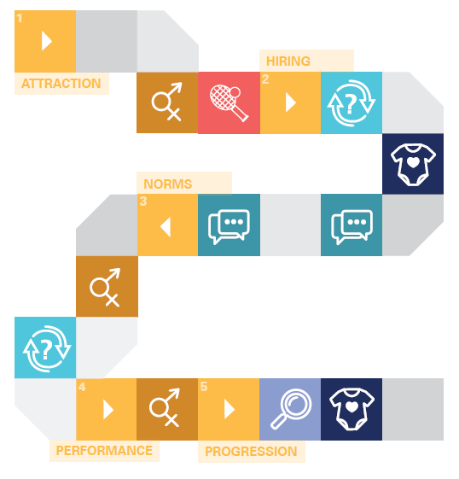

|  |  |
| --- | --- |
| **1. Attraction** |  |
| Subtle word choices impact on the application pool. Masculine language, including adjectives like ‘competitive’, ‘decisive’ and ‘determined’ can result in women perceiving they do not belong in the workplace.  Women are less likely than men to apply for roles if they do not meet 100% of the stated criteria. | Software programs that highlight stereotypical gendered words may help counteract this effect. Use programs like gender decoder to remove words or replace them with more neutral descriptions.  Reduce job requirements and focus only on essential skills and qualifications. |

|  |  |
| --- | --- |
|  | **Gender bias** – A preference for one gender over the other. Usually, a result of ingrained beliefs about gender roles and stereotypes. |
|  | **Affinity bias** – A tendency to gravitate toward people who share our interests, beliefs, and backgrounds. |

|  |  |
| --- | --- |
| **2. Hiring** |  |
| Studies show that women, LGBTIQA+ candidates, individuals with disabilities and older people are less likely to be hired than their peers. A bias for likability and natural chemistry is one of the most difficult to bust.  In hiring processes, mothers are less likely to receive a call back from potential employers, even when their resumes are identical to those of male applicants or childless women. | A blind, systematic process for reviewing applications and resumes will help you remain focused on the candidate’s qualifications and talents, as opposed to demographic characteristics.  Asking candidates to solve a work-related problem or skills test that mimic the kinds of tasks candidates will be doing can help you focus on the quality of a candidate’s work as opposed to unconsciously judging them on appearance, gender, age or personality.  Use an interview scorecard that grades candidate responses to questions on a predetermined scale. Ideally, the interview score card will be an independent data point linked to an anonymous CV review and work sample. |

|  |  |
| --- | --- |
|  | **Prove it Again bias** – Groups stereotyped as less competent – including women, individuals with disability, older Australians and LGBTIQA+ have to prove themselves over and over. |
|  | **Maternal wall bias** – Women with children see their commitment and competence questioned or face disapproval for being too career focused. |
|  | **Conformity bias** – We take behavioural cues from the actions of others rather than exercising independent judgement. |

|  |  |
| --- | --- |
| **3. Norms** |  |
| Women are 20% more likely than their male colleagues to volunteer for or be assigned ‘office housework’ such as organising, cleaning up after a meeting, scheduling meetings or taking notes. Meanwhile, ‘glamour work’ that leads to networking and promotion opportunities goes disproportionately towards men.  Women and people of Asian descent are more likely to have been raised believing that they should be communal, modest and helpful. The so called ‘modest mandate’ can lead individuals to hold back their thoughts or to speak in a tentative or deferential way.  Research shows that men are more likely than women to dominate conversation, with women typically participating about 25% less often than their male colleagues. | Systemise office ‘housework’ tasks by creating a spreadsheet or roster to ensure that the load falls equally on all staff.  Create mechanisms to track and reward lower profile contributions, including recognising staff mentoring in performance reviews.  If you are unsure if this is occurring in your meetings, start to track who is at the table and who is doing the talking. Apps such as All.ai can also be used to track the proportion of the meeting that your voice was heard.  Introduce office rules or principles around meeting etiquette, including not interrupting or speaking over others.  Train managers and leaders to create space for all staff to contribute to the conversation, for example explicitly asking quieter staff members to provide their thoughts and opinions.  When a female staff member is interrupted or discredited, call out the bias that may be at play. If it is not appropriate to call out bias during the meeting, politely raise the pattern of interruption you have noticed following the meeting. |

|  |  |
| --- | --- |
| **4. Performance** |  |
| Badge Cross with solid fillAn analysis of men and women’s written performance reviews found that women were more likely than men to receive vague feedback that did not offer specific details of what they had done well and what they could do to advance.  Men were more likely to receive longer reviews focused on technical competency compared with shorter reviews for women  Badge Cross with solid fillWhile men are judged on potential, mistakes made by ‘prove it again groups’, including women, are noticed more and remembered longer.  Badge Cross with solid fillA narrower range of workplace behaviour is accepted for women. While white men need to be authoritative and ambitious to succeed, women often risk being labelled aggressive or difficult if they behave in a similar fashion. | Checkmark with solid fillAdopt mechanisms that enhance the specificity of manager reviews. Develop a rubric for evaluation that clearly defines the criteria against which an employee’s performance will be assessed. Research shows that you are less likely to be influenced by instinct when you first agree to the criteria used in assessment.  Checkmark with solid fillTo guide managers performance reviews, consider the prompts to better reflect decisions and intentions. For example, prompt with statements like:   * I would always want this person on my team * I would award this person the highest possible compensation increases and bonuses * I would hire this person again * This person is ready for promotion today   Checkmark with solid fillDisrupt the ‘modesty mandate’ by giving staff tools to manage their own performance. Be clear that it is acceptable and expected to advocate for oneself.  Checkmark with solid fillInvite an independent and trained arbiter in to help call out bias as it manifests in real time. |

|  |  |
| --- | --- |
| **5. Progression** |  |
| Badge Cross with solid fillBadge Cross with solid fillManagers are more likely to underestimate the career aspirations of women with children, unfairly assuming they are less committed to progressing at work.  Women may face a “likeability” penalty if they attempt to negotiate for higher pay.  Badge Cross with solid fillBadge Cross with solid fillWomen are less likely than their male peers to receive sponsorship and stretch opportunities than their male colleagues, a fact which is often attributed to affinity bias.  Women are less likely than men to reapply for roles and promotions after narrowly missing out. | Checkmark with solid fillCreate conversation prompts for managers that requires them to discuss and clarify performance goals and ambitions with team members.  Checkmark with solid fillFrequently review salaries for parity between genders and commit to make changes if this is not occurring.  Checkmark with solid fillMonitor assignment opportunities to identify and disrupt biased sponsorship patterns.  Checkmark with solid fillInvest in a sponsorship (or reciprocal mentorship) program which connects senior male leaders with diverse talent. Encourage them to use their power and influence to help women to advance.  Checkmark with solid fillMake a habit of following up with unsuccessful candidates with an email or phone call. Provide feedback and encourage them to re-apply for roles in future. |

|  |  |
| --- | --- |
|  | **Tightrope bias** – A narrower range of workplace behaviours is accepted from some groups than from others. |